Session 11 - 1
import java.io.*;
import java.util.*;
import java.time.LocalDate;
class Result {

public static String findDay(int month, int day, int year) {
return LocalDate.of(year, month, day).getDayOfWeek().name();
}
}
public class Solution {
public static void main(String[] args) throws IOException {
BufferedReader bufferedReader = new BufferedReader(new InputStreamReader(System.in));
BufferedWriter bufferedWriter = new BufferedWriter(new FileWriter(System.getenv("OUTPUT_PATH")));
String[] firstMultipleInput = bufferedReader.readLine().replaceAll("\\s+$", "").split(" ");
int month = Integer.parseInt(firstMultipleInput[0]);
int day = Integer.parseInt(firstMultipleInput[1]);
int year = Integer.parseInt(firstMultipleInput[2]);
String res = Result.findDay(month, day, year);
bufferedWriter.write(res);
bufferedWriter.newLine();
bufferedReader.close();
bufferedWriter.close();
}
}

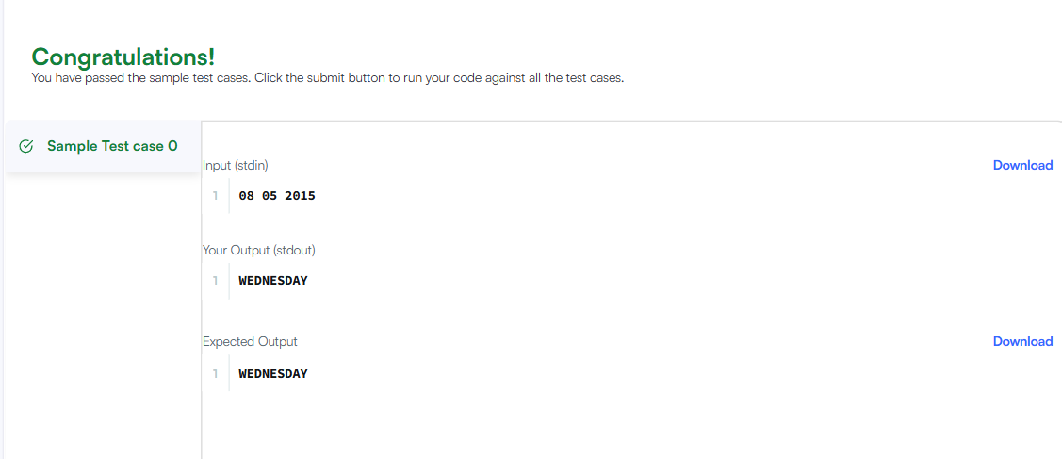

Session 11 - 2
import java.time.LocalDate;
import java.time.temporal.ChronoUnit;
class Solution {
public int daysBetweenDates(String date1, String date2) {
LocalDate d1 = LocalDate.parse(date1);
LocalDate d2 = LocalDate.parse(date2);

return (int) Math.abs(ChronoUnit.DAYS.between(d1, d2));
}
}

